**Project Design Phase-II**

**Data Flow Diagram**

|  |  |
| --- | --- |
| Date | 15 October 2022 |
| TEAM ID | PNT2022TMID49391 |
| Project Name | News Tracker Application |
| Maximum Marks | 4 marks |

**Data Flow Diagram:**

A Data flow diagram is a traditional visual representation of the information flows within a system. A neat and clear DFD can depict the right amount of the system requirement graphically. It shows how data enters and leaves the system, what changes the information and where data is stored.

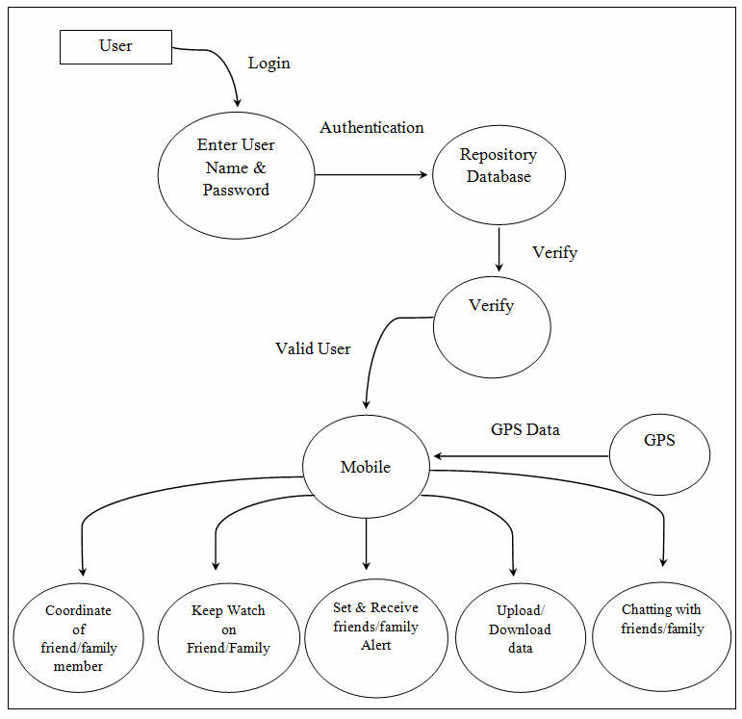

|  |  |  |  |  |  |  |
| --- | --- | --- | --- | --- | --- | --- |
| **User Type** | **Functional**  **Requirement**  **(EPIC)** | **User Story**  **Number** | **User Story/Task** | **Acceptance Criteria** | **Priority** | **Release** |
| Customer (Mobile user) | Installation | USN-1 | As a user, I installed the app for day-to-day update and feeds | My app will be installed on home screen | Medium |  |
| Customer (Mobile user) |  | USN-2 | As a user, I can register for the application by entering my email, password,  confirming my password and phone number. | I can access my account / dashboard | High | Sprint-1 |
|  |  | USN-3 | As a user, I will receive confirmation email once I have registered for the app | I can receive confirmation email &SMS | High | Sprint-1 |
|  |  | USN-4 | As a user, I can register for the application through Gmail | I can register & access the dashboard with Gmail account Login | Medium | Sprint-1 |
|  | Login | USN-6 | As a user, I can log into the application by entering email & password | I can login to the official page | High | Sprint-1 |
|  | Dashboard | USN-7 | Day to day news, feeds, categories, tech news and other updates | I can see all the news which I wanted | High | Sprint-1 |
| Customer (Web  user) | Browsing | USN-8 | Enter the web site on the browser | I can login  Through  browser | Medium | Sprint-1 |